* 1. **Selecting Template**

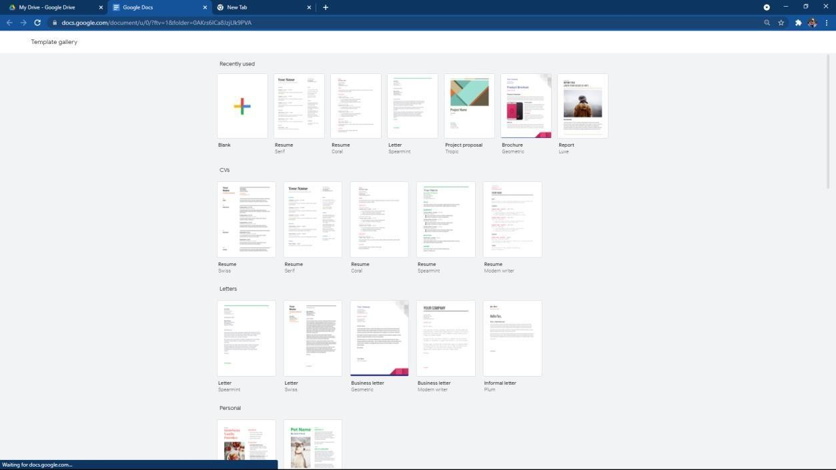

* 1. **Creating Resume**

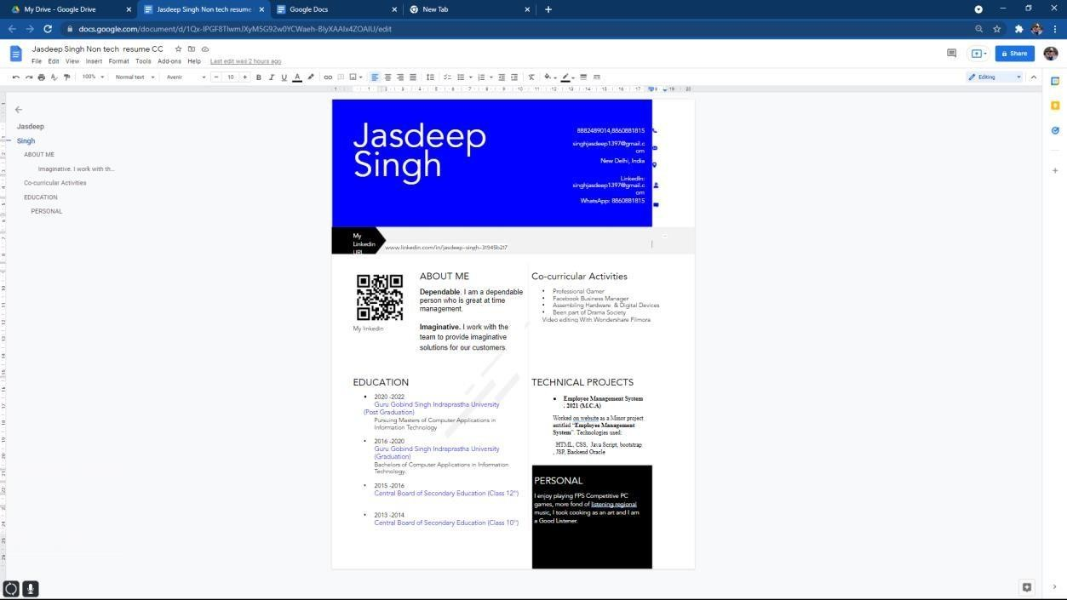

CHIRAG BITONI

**Q5. Install Virtualbox/VMware Workstation with different flavours of linux or windows OS on top of windows7 or 8.**

11



|  |
| --- |
| Cloud Computing |
| * **Installation Guide**   + **Virtual Box**   **Ubuntu** |
|  |

NAME: CHIRAG BITONI

PLACE. DELHI

Email:chiragbitoni4994@gmail.com